**Aim:** **Draw the** **Stacked Line chart using plotly, matplotlib and seaborn libraries in python on random dataset**

**IDE:** Excel, Tableau, Spyder IDE

**Theory:**

**Stacked Line Chart**

Stacked Line charts show the contribution to trends in the data. This is done by stacking lines on top of each other. Stacked Line charts are used with data which can be placed in an order, from low to high. The charts are used when you have more than one data column which all add up to the total trend.

Creating Graph from Two Sets of Original Data

1. Highlight both series
2. Click Insert
3. Select Line Graph
4. Click Line with Markers

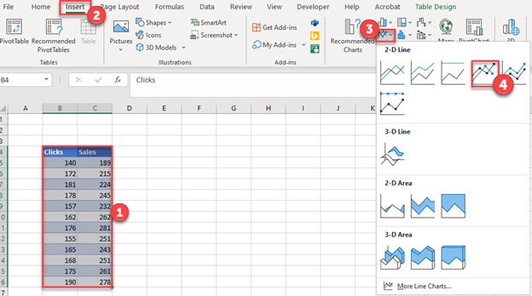

Final Graph with Multiple Lines

Below you can see what the graph looks like as we compare how clicks change and sales change in the same period. This can help determine if there are trends among the two datasets.

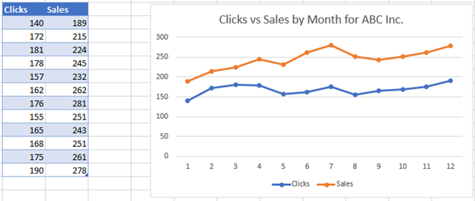

Adding to Graph in Order to Create Multiple Lines Graph

Instead of the scenario above, in this section, we’ll show what to do if you want to add to the graph to create a multiple lines graph. We’ll start with a single line graph below and show how to add another dataset.

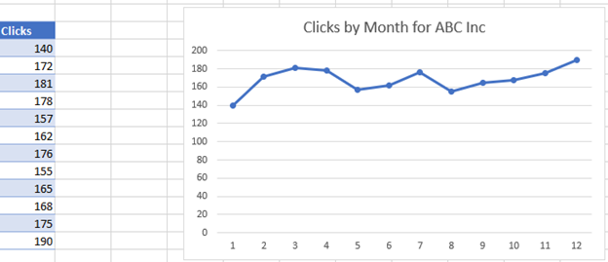

1. Right click on the graph
2. Click Select Data

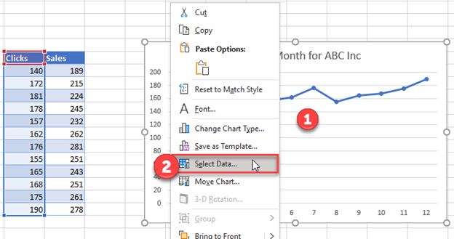

1. Click Add under Series

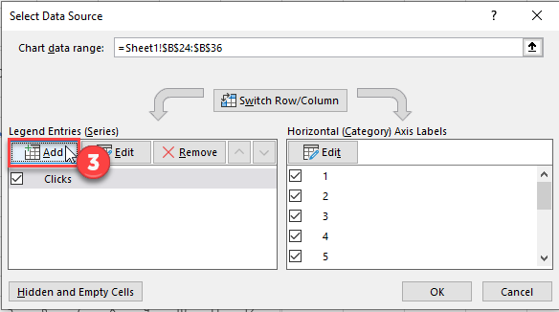

1. Select Series Name with updated header for new series
2. Select Series Values with updated values for new series

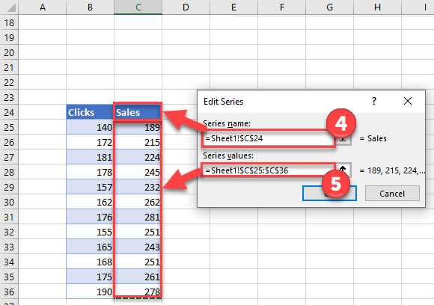

Final Graph with Multiple Lines

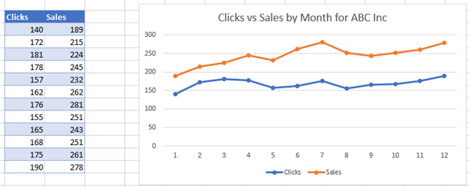

**Pre Lab Exercise:**

1. How do I create a stacked line chart in Excel?

____________________________________________________________________________________________________________________________________________________________________________________________________________________________________________________________

**____________________________________________________________________________________**

**________________________________________________________________________________________________________________________________________________________________________**

1. How can I add data labels to the stacked line chart in Excel?

____________________________________________________________________________________________________________________________________________________________________________________________________________________________________________________________

**____________________________________________________________________________________**

**________________________________________________________________________________________________________________________________________________________________________**

1. How to change the colors of individual lines in a stacked line chart?

____________________________________________________________________________________________________________________________________________________________________________________________________________________________________________________________

**Pre-Lab Tasks:**

Perform the following tasks using Excel:

Task 1: Draw Stacked line chart using superstore data (Order Date vs. Sales & Profit)

**Results:-**

Task 2: Draw line chart with bar chart using superstore data (Order Date vs. Sales (Profit bar chart))

(Considered Measure name dimension))

**Results:-**

Task 3: Draw Stacked line chart using superstore data (Order Date vs. Sales, Profit, Quantity)

**Results:-**

**In-Lab Tasks:**

Perform the following tasks using Tableau:

Task 1: Draw Stacked line chart using superstore data (Order Date vs. Sales & Profit)

**Results:-**

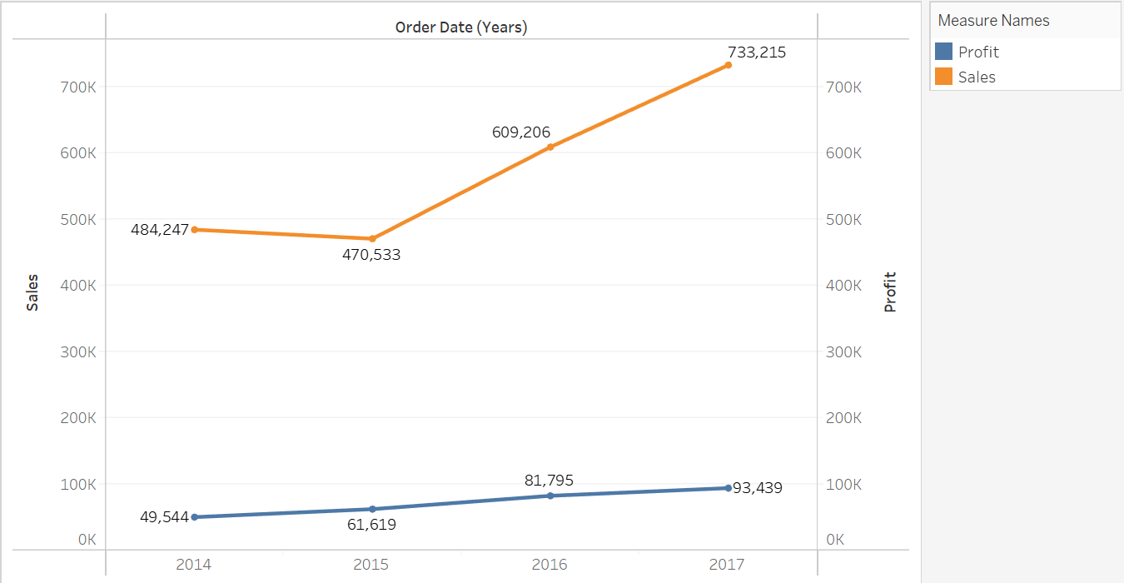

Task 2: Draw line chart with bar chart using superstore data (Order Date vs. Sales (Profit bar chart))

(Considered Measure name dimension))

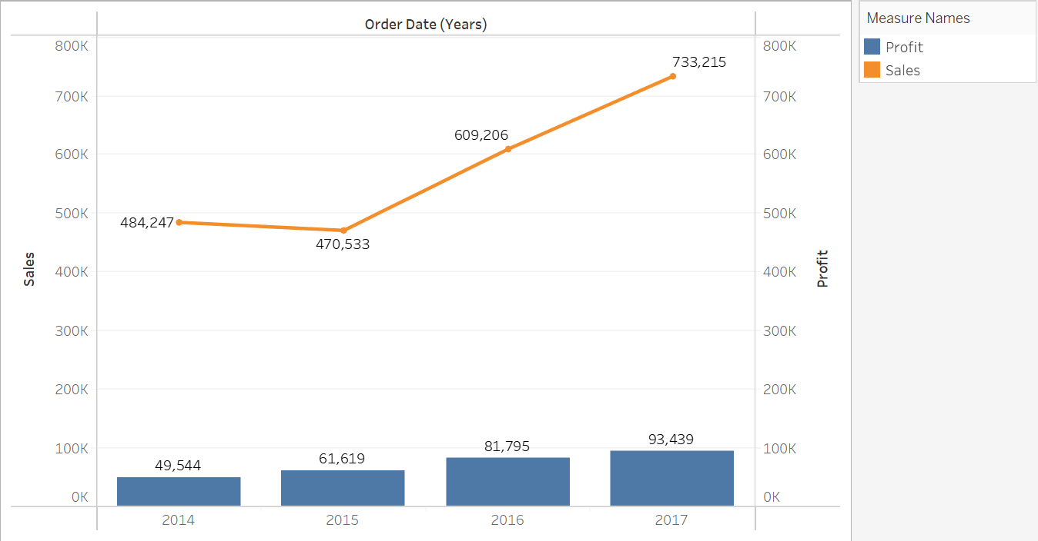**Results:-**

Task 3: Draw Stacked line chart using superstore data (Order Date vs. Sales, Profit, Quantity)

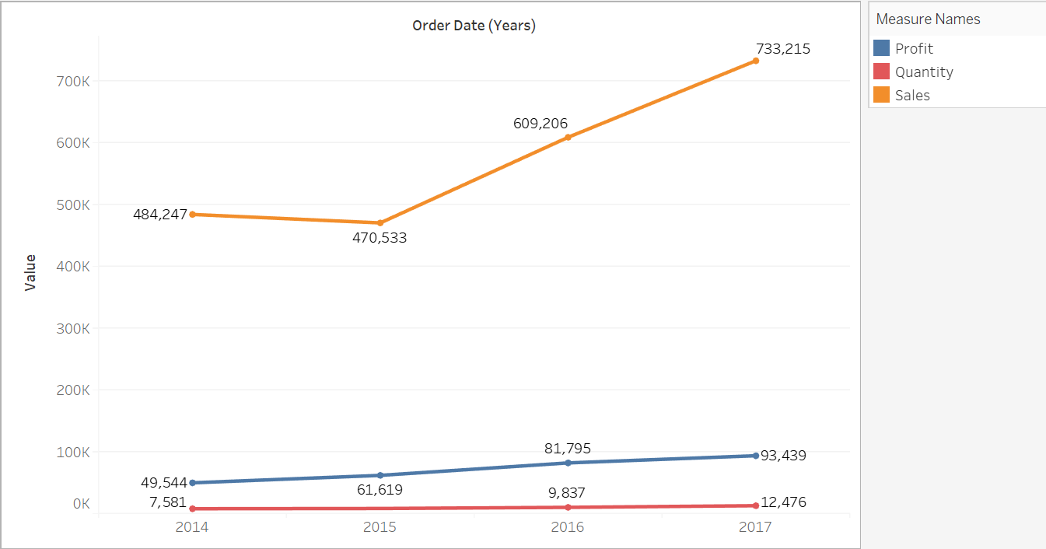**Results:-**

**Post-Lab Tasks:**

Perform the following tasks using Python:

**Pre-Requisites :-**

import numpy as np

import seaborn as sns

import matplotlib.pyplot as plt

import pandas as pd

Dataset = pd.read_excel('D:/Aryan Data/Usefull Data/Semester - 4/Data Visulization and Dashboards/Lab Manual/Exp-6 Creating Line chart multiple/Sample - Superstore.xlsx','Orders')

Task 1: Draw Stacked line chart using superstore data (Order Date vs. Sales & Profit)

**Code :-**

plt.figure(figsize=(16, 8))

Years = sorted(set(Dataset['Year']))

Sales = Dataset.groupby('Year')['Sales'].sum()

Profit = Dataset.groupby('Year')['Profit'].sum()

plt.plot(Years, Sales, color='blue', linewidth=2, label='Sales')

plt.plot(Years, Profit, color='red', linewidth=2, label='Profit')

plt.legend()

plt.xlabel('Year')

plt.ylabel('Amount')

plt.title('Stacked Line Chart Sales and Profit over Years')

plt.show()

**Results:-**

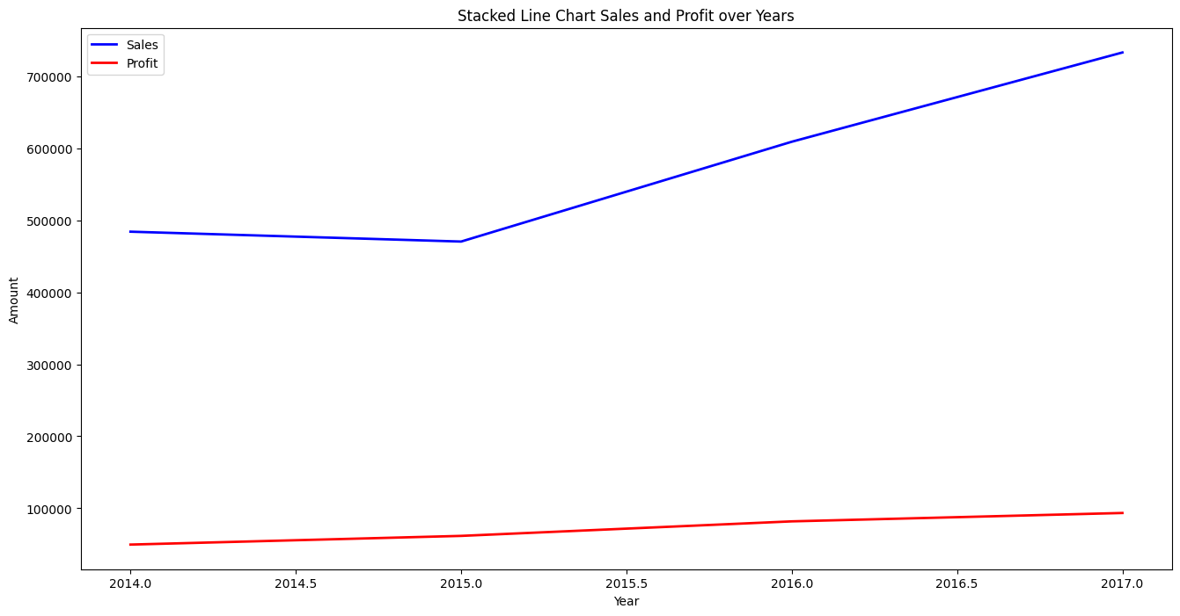

Task 2: Draw line chart with bar chart using superstore data (Order Date vs. Sales (Profit bar chart)) (Considered Measure name dimension))

**Code :-**

plt.figure(figsize=(16, 8))

Years = sorted(set(Dataset['Year']))

Sales = Dataset.groupby('Year')['Sales'].sum()

Profit = Dataset.groupby('Year')['Profit'].sum()

plt.bar(Years, Profit, color='red',width=0.5,label='Profit')

plt.plot(Years, Sales, color='blue', linewidth=2, label='Sales')

plt.title('Combined Line and Bar Chart: Sales & Profit over Time')

plt.legend()

plt.show()

**Results:-**

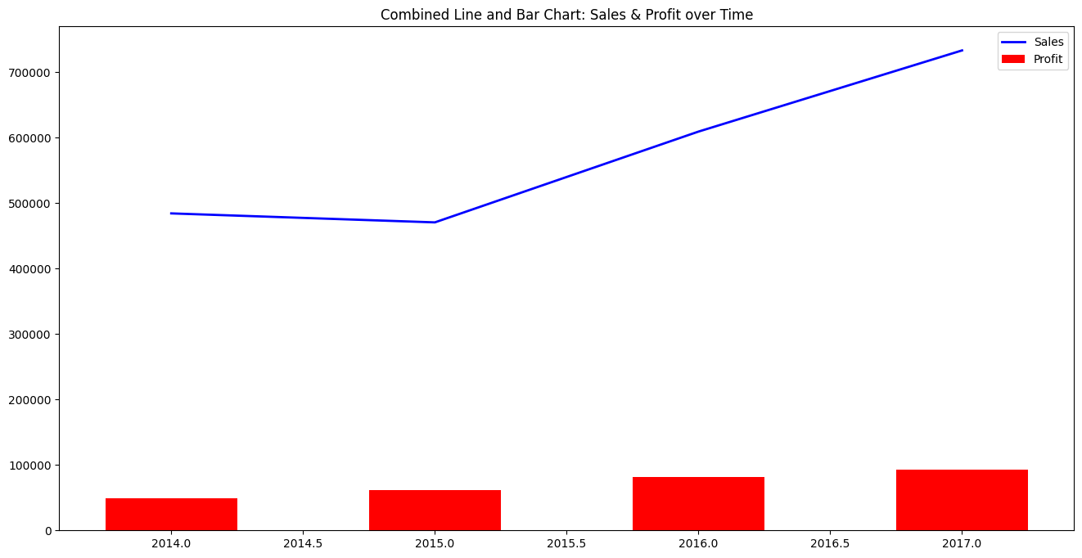

Task 3: Draw Stacked line chart using superstore data (Order Date vs. Sales, Profit, Quantity)

**Code :-**

plt.figure(figsize=(16, 8))

Years = sorted(set(Dataset['Year']))

Sales = Dataset.groupby('Year')['Sales'].sum()

Profit = Dataset.groupby('Year')['Profit'].sum()

Quantity = Dataset.groupby('Year')['Quantity'].sum()

plt.plot(Years, Sales, color='blue', linewidth=2, label='Sales')

plt.plot(Years, Profit, color='red', linewidth=2, label='Profit')

plt.plot(Years,Quantity, color='green', linewidth=2, label='Quantity')

plt.legend()

plt.xlabel('Year')

plt.ylabel('Amount')

plt.title('Stacked Line Chart for Sales,Profit and Quantity over Year')

plt.show()

**Results :-**

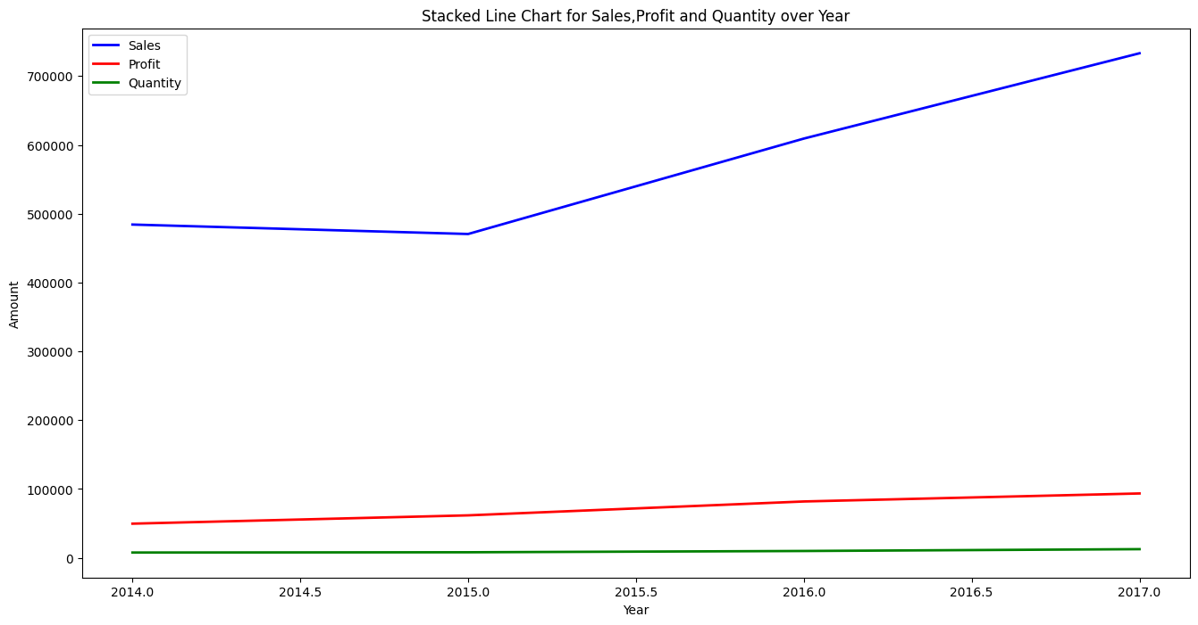

Reference Link: <https://help.tableau.com/current/pro/desktop/en-us/qs_combo_charts.htm>

**Observation and Result Analysis:**

Write the final observation and process corresponding to each task

**________________________________________________________________________________________________________________________________________________________________________________________**

**____________________________________________________________________________________________**

**________________________________________________________________________________________________________________________________________________________________________________________**

**____________________________________________________________________________________________**

**________________________________________________________________________________________________________________________________________________________________________________________**

**____________________________________________________________________________________________**

**Post Lab Exercise:**

**Python Implementation**

**Reference Link:** [**https://www.kaggle.com/code/alaasedeeq/superstore-analysis-with-cufflinks-clustering?scriptVersionId=69225428**](https://www.kaggle.com/code/alaasedeeq/superstore-analysis-with-cufflinks-clustering?scriptVersionId=69225428)